Building a Jenkins Pipeline SOP



Table of Contents

1. Building a Jenkins Pipeline 3
1.1 Description 3
1.2 Architecture Diagram 3
1.3 Lab Steps 4
1.4 Troubleshooting 5
1.5 Supporting References 6

Building a Jenkins Pipeline

Description
Jenkins Pipeline allows you to treat all of your build logic as code. You can also integrate your build into a larger automated process that includes things like automated deployment. Pipelines are especially useful as you transition from doing CI to doing CI+CD.
In this hands-on lab, you will build a simple pipeline using Jenkins server by installing it on an EC2 instance. You will gain a basic familiarity with how a Jenkins Pipeline is created and how to implement simple build logic within a pipeline.

Architecture Diagram
The diagram below displays a visual representation of the application architecture:
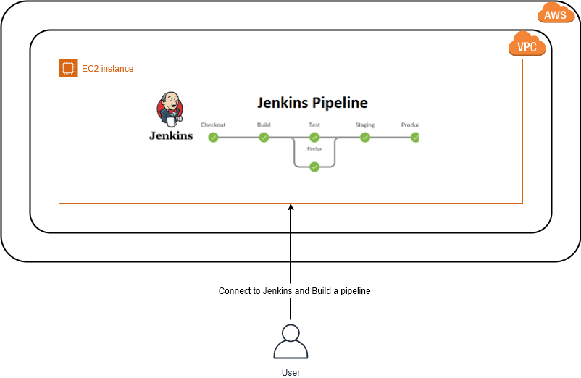

Lab Steps
Follow the steps outlined below to achieve the objective of this lab exercise:

- Build a Jenkins server on EC2:
  - Navigate to EC2 console and Launch an Amazon Linux 2 instance.
  - Make sure that the security group you create for your instance allows traffic on ports TCP/22 with source as MyIp and TCP/80 open for internet so you will be able to connect to your instance via SSH and access it via browser using its DNS.
  - SSH into your instance either using PuTTY or directly from the console using session manager by attaching CCL-EC2-Role.
  - Update the repositories and install Docker and Git:
$ sudo yum update -y
$ sudo yum install -y docker git
  - Add the Jenkins repository and install Jenkins from there:
$ sudo wget -O
/etc/yum.repos.d/jenkins.repohttp://pkg.jenkins.io/redhat/jenkins.repo
$ sudo rpm -import https://pkg.jenkins.io/redhat/jenkins.io.key
$ sudo yum install jenkins -y
$ sudo usermod -aG root jenkins # Add jenkins to the root group
  - Add the jenkins user to the docker group to allow Jenkins to build our Docker images:
# Add Jenkins and current user to the Docker group
$ sudo usermod -aG docker $USER
$ sudo usermod -aG docker jenkins
  - Start the services:
$ sudo service jenkins start $ sudo service docker start
  - If you are not able to start Jenkins server, install java and verify whether it is installed and again start the jenkins service:
sudo yum install java-1.8.0-openjdk java -version
  - As Jenkins typically uses port TCP/8080, configure iptables routing rules to redirect the traffic:
$ sudo iptables -I INPUT 1 -p tcp --dport 8080 -j ACCEPT
$ sudo iptables -I INPUT 1 -p tcp --dport 80 -j ACCEPT
$ sudo iptables -A PREROUTING -t nat -i eth0 -p tcp --dport 80 -j REDIRECT --to-port 8080
  - To use HTTPS you need to include rules to redirect traffic for port 443:
$ sudo iptables -I INPUT 1 -p tcp --dport 8443 -j ACCEPT
$ sudo iptables -I INPUT 1 -p tcp --dport 443 -j ACCEPT
$ sudo iptables -A PREROUTING -t nat -i eth0 -p tcp --dport 443 j REDIRECT --to-port 8443

  - Copy the public IP or DNS name of your EC2 instance and paste it in your browser. You should be able to see the Jenkins home page.
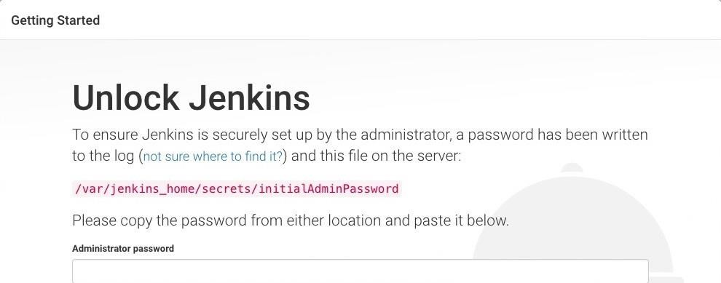
l.

G
et the password from the indicated file:

$ sudo cat /var/lib/jenkins/secrets/initialAdminPassword

- Configuring pipeline using Jenkins:
  - Install the recommended plugins and create an Admin account in the following steps. At this point you should be able to login.
  - Click on New Item in the left pane of the Jenkins console, and enter an item name (Ex. First Build) and select Freestyle project.
  - Under Build select Execute Shell and enter command as: echo My first Build using Jenkins and click on Save.
  - Create two new items (Second Build, Third Build) by following Steps b and c by changing the shell commands.
Note: You can individually run the jobs by selecting BuildNow and see the output.
  - Select the first job and click on configure and under PostBuildActoins select Build other project by providing Second Build. Repeat the same for Second Build.
Note: Now if you trigger first job you can see that Second Build comes under Build Queue. If you navigate inside the first build item output, you can find success output with triggers.

Troubleshooting
S. No | Problem | Solution
1 | Connection Timed out error | Check if security group is configured properly with port 80 open
2 | Build failed inside Jenkins | Check if build is configured properly and command is given right.
3 | Build pipeline not running | Post Build Actions must be set properly.

Supporting References
Refer the below links for additional information:

- https://aws.amazon.com/config/
- https://docs.aws.amazon.com/config/latest/developerguide/managing-aws-managed-rules.html

